Shop AmazonSmile and Donate to NCUMC!

AmazonSmile is a simple and automatic way for you to support NCUMC every time you shop, at no cost to you. When you shop at smile.amazon.com, you’ll find the exact same low prices, vast selection and convenient shopping experience as Amazon.com, with the added bonus that Amazon will donate a portion of the purchase price to NCUMC.

The AmazonSmile Foundation will donate 0.5% of the purchase price (amount paid for the item minus any rebates and excluding shipping & handling, gift-wrapping fees, taxes, or service charges) from your eligible smile.amazon.com purchases. Tens of millions of products are eligible for donations. You will see eligible products marked “Eligible for AmazonSmile donation” on their smile.amazon.com product detail pages. Recurring Subscribe-and-Save purchases and subscription renewals are not currently eligible to generate donations.

Which products on AmazonSmile are eligible for charitable donations?
Tens of millions of products on AmazonSmile are eligible for donations. You will see eligible products marked “Eligible for AmazonSmile donation” on their product detail pages. Recurring Subscribe-and-Save purchases and subscription renewals are not currently eligible.

Can I use my existing Amazon.com account on AmazonSmile?
Yes, you use the same account on Amazon.com and AmazonSmile. Your shopping cart, Wish List, wedding or baby registry, and other account settings are also the same.

How do I select NCUMC as my charity when shopping on AmazonSmile?
On your first visit to AmazonSmile at smile.amazon.com, you need to log in to your account. Then, enter New Covenant United Methodist Church Lady Lake as your charitable organization before you begin shopping. Your selection will be remembered, and then every eligible purchase you make at smile.amazon.com will result in a donation to NCUMC!

Shop AmazonSmile and Donate to NCUMC!

AmazonSmile is a simple and automatic way for you to support NCUMC every time you shop, at no cost to you. When you shop at smile.amazon.com, you’ll find the exact same low prices, vast selection and convenient shopping experience as Amazon.com, with the added bonus that Amazon will donate a portion of the purchase price to NCUMC.

The AmazonSmile Foundation will donate 0.5% of the purchase price (amount paid for the item minus any rebates and excluding shipping & handling, gift-wrapping fees, taxes, or service charges) from your eligible smile.amazon.com purchases. Tens of millions of products are eligible for donations. You will see eligible products marked “Eligible for AmazonSmile donation” on their smile.amazon.com product detail pages. Recurring Subscribe-and-Save purchases and subscription renewals are not currently eligible to generate donations.

Which products on AmazonSmile are eligible for charitable donations?
Tens of millions of products on AmazonSmile are eligible for donations. You will see eligible products marked “Eligible for AmazonSmile donation” on their product detail pages. Recurring Subscribe-and-Save purchases and subscription renewals are not currently eligible.

Can I use my existing Amazon.com account on AmazonSmile?
Yes, you use the same account on Amazon.com and AmazonSmile. Your shopping cart, Wish List, wedding or baby registry, and other account settings are also the same.

How do I select NCUMC as my charity when shopping on AmazonSmile?
On your first visit to AmazonSmile at smile.amazon.com, you need to log in to your account. Then, enter New Covenant United Methodist Church Lady Lake as your charitable organization before you begin shopping. Your selection will be remembered, and then every eligible purchase you make at smile.amazon.com will result in a donation to NCUMC!
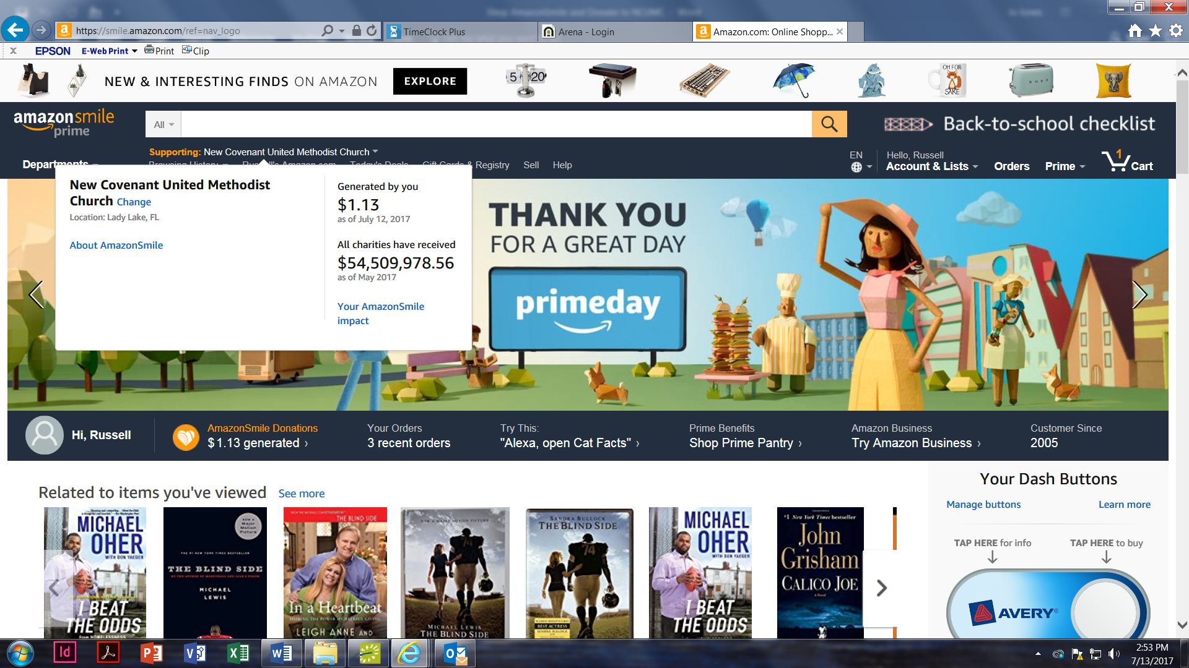
Remember, only purchases made at smile.amazon.com,
(not www.amazon.com or the mobile app,) generate AmazonSmile donations.
If you need assistance setting up NCUMC as your charity, please contact Jo Jones at (352) 750-4529 or jjones@newcovenantumc-fl.org.

Remember, only purchases made at smile.amazon.com,
(not www.amazon.com or the mobile app,) generate AmazonSmile donations.
If you need assistance setting up NCUMC as your charity, please contact Jo Jones at (352) 750-4529 or jjones@newcovenantumc-fl.org.

